**Differential Equations:**

* **System of Differential Equations**

### Differential Equations in Matrix Form

### First-Order Linear ODE

### Differential Equation with Condition

### Nonlinear Differential Equation with Initial Condition

### Second-Order ODE with Initial Conditions

### Third-Order ODE with Initial Conditions

### More ODE Examples

**System of Differential Equations**

Solve this system of linear first-order differential equations.

*dudt*=3*u*+4*v*,*dvdt*=−4*u*+3*v*.

First, represent *u* and *v* by using syms to create the symbolic functions u(t) and v(t).

syms u(t) v(t)

Define the equations using == and represent differentiation using the diff function.

ode1 = diff(u) == 3*u + 4*v;

ode2 = diff(v) == -4*u + 3*v;

odes = [ode1; ode2]

odes(t) =

diff(u(t), t) == 3*u(t) + 4*v(t)

diff(v(t), t) == 3*v(t) - 4*u(t)

Solve the system using the dsolve function which returns the solutions as elements of a structure.

S = dsolve(odes)

S =

struct with fields:

v: [1×1 sym]

u: [1×1 sym]

To access u(t) and v(t), index into the structure S.

uSol(t) = S.u

vSol(t) = S.v

uSol(t) =

C2*cos(4*t)*exp(3*t) + C1*sin(4*t)*exp(3*t)

vSol(t) =

C1*cos(4*t)*exp(3*t) - C2*sin(4*t)*exp(3*t)

Alternatively, store u(t) and v(t) directly by providing multiple output arguments.

[uSol(t), vSol(t)] = dsolve(odes)

uSol(t) =

C2*cos(4*t)*exp(3*t) + C1*sin(4*t)*exp(3*t)

vSol(t) =

C1*cos(4*t)*exp(3*t) - C2*sin(4*t)*exp(3*t)

The constants C1 and C2 appear because no conditions are specified. Solve the system with the initial conditions u(0) == 0 and v(0) == 0. The dsolve function finds values for the constants that satisfy these conditions.

cond1 = u(0) == 0;

cond2 = v(0) == 1;

conds = [cond1; cond2];

[uSol(t), vSol(t)] = dsolve(odes,conds)

uSol(t) =

sin(4*t)*exp(3*t)

vSol(t) =

cos(4*t)*exp(3*t)

Visualize the solution using fplot. Before R2016a, use ezplot instead.

fplot(uSol)

hold on

fplot(vSol)

grid on

legend('uSol','vSol','Location','best')

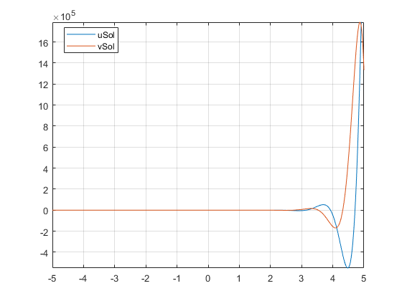

**Differential Equations in Matrix Form**

Solve differential equations in matrix form by using dsolve.

Consider this system of differential equations.

*dxdt*=*x*+2*y*+1,*dydt*=−*x*+*y*+*t*.

The matrix form of the system is

[*x*'*y*']=[1−121][*xy*]+[1*t*].

Let

*Y*=[*xy*],*A*=[1−121],*B*=[1*t*].

The system is now Y′ = AY + B.

Define these matrices and the matrix equation.

syms x(t) y(t)

A = [1 2; -1 1];

B = [1; t];

Y = [x; y];

odes = diff(Y) == A*Y + B

odes(t) =

diff(x(t), t) == x(t) + 2*y(t) + 1

diff(y(t), t) == t - x(t) + y(t)

Solve the matrix equation using dsolve. Simplify the solution by using the simplify function.

[xSol(t), ySol(t)] = dsolve(odes);

xSol(t) = simplify(xSol(t))

ySol(t) = simplify(ySol(t))

xSol(t) =

(2*t)/3 + 2^(1/2)*C2*exp(t)*cos(2^(1/2)*t) + 2^(1/2)*C1*exp(t)*sin(2^(1/2)*t) + 1/9

ySol(t) =

C1*exp(t)*cos(2^(1/2)*t) - t/3 - C2*exp(t)*sin(2^(1/2)*t) - 2/9

The constants C1 and C2 appear because no conditions are specified.

Solve the system with the initial conditions u(0) = 2 and v(0) = –1. When specifying equations in matrix form, you must specify initial conditions in matrix form too. dsolve finds values for the constants that satisfy these conditions.

C = Y(0) == [2; -1];

[xSol(t), ySol(t)] = dsolve(odes,C)

xSol(t) =

(2*t)/3 + (17*exp(t)*cos(2^(1/2)*t))/9 - (7*2^(1/2)*exp(t)*sin(2^(1/2)*t))/9 + 1/9

ySol(t) =

- t/3 - (7*exp(t)*cos(2^(1/2)*t))/9 - (17*2^(1/2)*exp(t)*sin(2^(1/2)*t))/18 - 2/9

Visualize the solution using fplot. Before R2016a, use ezplot instead.

clf

fplot(ySol)

hold on

fplot(xSol)

grid on

legend('ySol','xSol','Location','best')

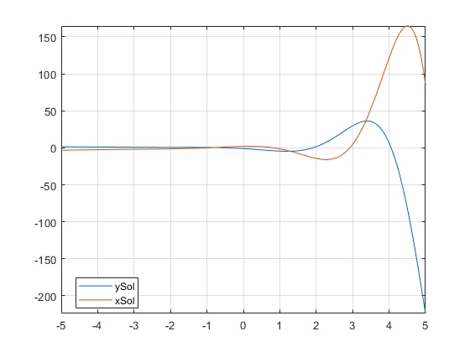

**First-Order Linear ODE**

Solve this differential equation.

*dydt*=*ty*.

First, represent *y* by using syms to create the symbolic function y(t).

syms y(t)

Define the equation using == and represent differentiation using the diff function.

ode = diff(y,t) == t*y

ode(t) =

diff(y(t), t) == t*y(t)

Solve the equation using dsolve.

ySol(t) = dsolve(ode)

ySol(t) =

C1*exp(t^2/2)

**Differential Equation with Condition**

In the previous solution, the constant C1 appears because no condition was specified. Solve the equation with the initial condition y(0) == 2. The dsolve function finds a value of C1 that satisfies the condition.

cond = y(0) == 2;

ySol(t) = dsolve(ode,cond)

ySol(t) =

2*exp(t^2/2)

**Nonlinear Differential Equation with Initial Condition**

Solve this nonlinear differential equation with an initial condition. The equation has multiple solutions.

(*dydt*+*y*)2=1,*y*(0)=0.

syms y(t)

ode = (diff(y,t)+y)^2 == 1;

cond = y(0) == 0;

ySol(t) = dsolve(ode,cond)

ySol(t) =

exp(-t) - 1

1 - exp(-t)

**Second-Order ODE with Initial Conditions**

Solve this second-order differential equation with two initial conditions.

*d*2*ydx*2=cos(2*x*)−*y*,*y*(0)=1,*y*'(0)=0.

Define the equation and conditions. The second initial condition involves the first derivative of y. Represent the derivative by creating the symbolic function Dy = diff(y) and then define the condition using Dy(0)==0.

syms y(x)

Dy = diff(y);

ode = diff(y,x,2) == cos(2*x)-y;

cond1 = y(0) == 1;

cond2 = Dy(0) == 0;

Solve ode for y. Simplify the solution using the simplify function.

conds = [cond1 cond2];

ySol(x) = dsolve(ode,conds);

ySol = simplify(ySol)

ySol(x) =

1 - (8*sin(x/2)^4)/3

**Third-Order ODE with Initial Conditions**

Solve this third-order differential equation with three initial conditions.

*d*3*udx*3=*u*,*u*(0)=1, *u*′(0)=−1, *u*′′(0)=*π*.

Because the initial conditions contain the first- and second-order derivatives, create two symbolic functions, Du = diff(u,x) and D2u = diff(u,x,2), to specify the initial conditions.

syms u(x)

Du = diff(u,x);

D2u = diff(u,x,2);

Create the equation and initial conditions, and solve it.

ode = diff(u,x,3) == u;

cond1 = u(0) == 1;

cond2 = Du(0) == -1;

cond3 = D2u(0) == pi;

conds = [cond1 cond2 cond3];

uSol(x) = dsolve(ode,conds)

uSol(x) =

(pi*exp(x))/3 - exp(-x/2)*cos((3^(1/2)*x)/2)*(pi/3 - 1) -...

(3^(1/2)*exp(-x/2)*sin((3^(1/2)*x)/2)*(pi + 1))/3

**More ODE Examples**

This table shows examples of differential equations and their Symbolic Math Toolbox™ syntax. The last example is the Airy differential equation, whose solution is called the Airy function.

| **Differential Equation** | **Commands** |
| --- | --- |
| *dydt*+4*y*(*t*)=*e*−*t*,*y*(0)=1. | syms y(t)  ode = diff(y)+4*y == exp(-t);  cond = y(0) == 1;  ySol(t) = dsolve(ode,cond)  ySol(t) =  exp(-t)/3 + (2*exp(-4*t))/3 |
| 2*x*2*d*2*ydx*2+3*xdydx*−*y*=0. | syms y(x)  ode = 2*x^2*diff(y,x,2)+3*x*diff(y,x)-y == 0;  ySol(x) = dsolve(ode)  ySol(x) =  C2/(3*x) + C3*x^(1/2) |
| The Airy equation.  *d*2*ydx*2=*xy*(*x*). | syms y(x)  ode = diff(y,x,2) == x*y;  ySol(x) = dsolve(ode)  ySol(x) =  C1*airy(0,x) + C2*airy(2,x) |